



Informatics Institute of Technology  
In collaboration with

**University of Westminster**

Advanced Client-Side Development

5COSC026C

Assessment

Portfolio with in-class test

S.D.Vishal Oshada Sudasinghe

20240036 / w2119833

[Vishal.20240036@iit.ac.lk](mailto:Vishal.20240036@iit.ac.lk)

TUT GRP 01

**Table of Contents**

**1.** **Final Website Screenshots** 3

1. Home Page 3

2. Projects Page 4

3. Blogs Page 5

4. About Page 6

**2.** **Portfolio Code** 7

1. Index.html 7

2. Projects.html 7

3. Blogs.html 7

4. About.html 7

5. Styles.css 7

**3.** **Diary** 8

**4.** **CSS Implementation** 16

**5.** **Code Validation** 21

**6.** **Version history** 23

**7.** **References** 28

## **Final Website Screenshots**

### Home Page

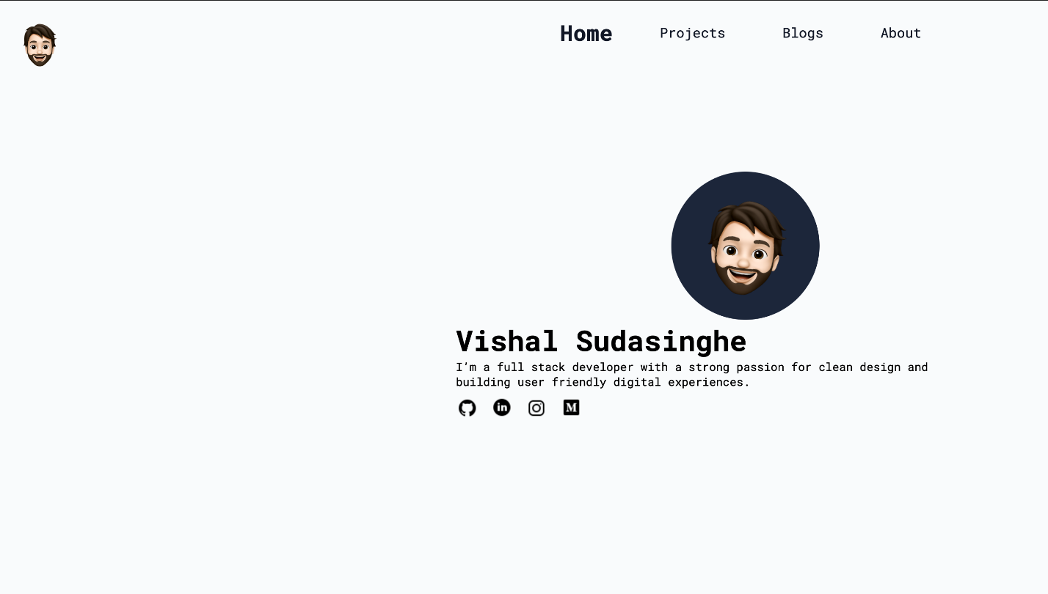

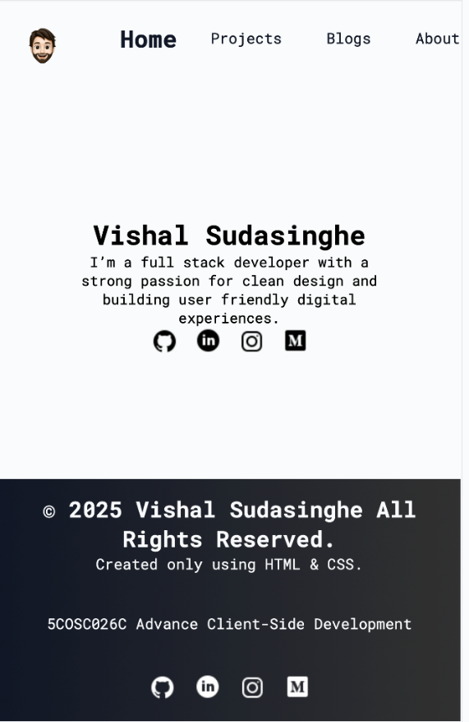

### Projects Page

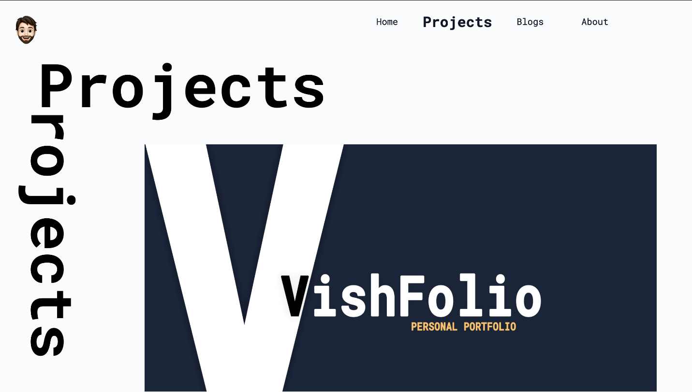

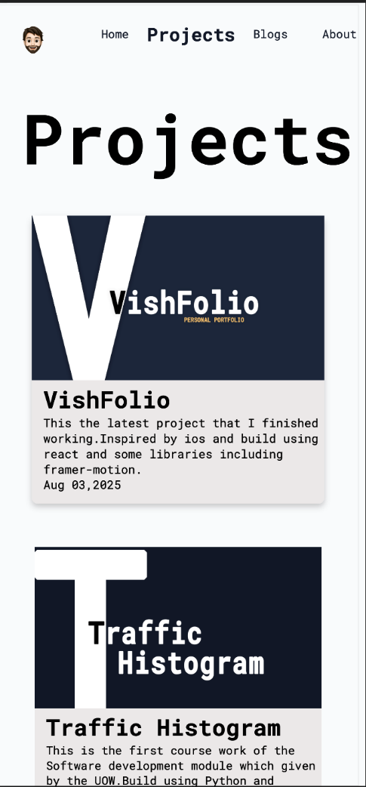

### Blogs Page

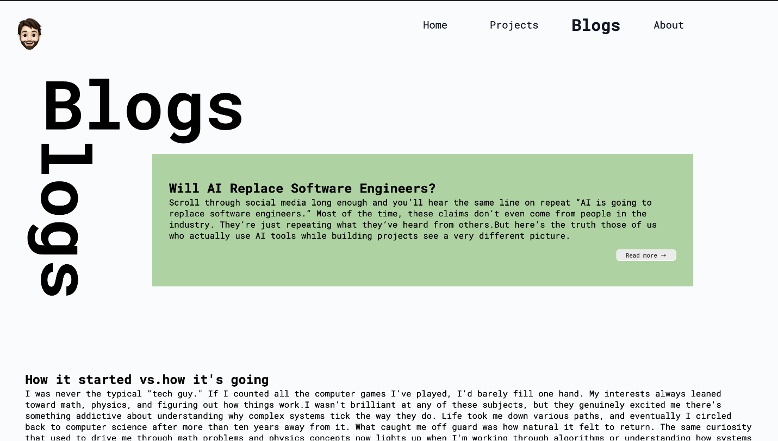

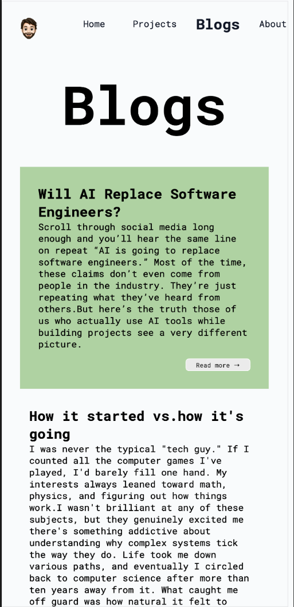

### About Page

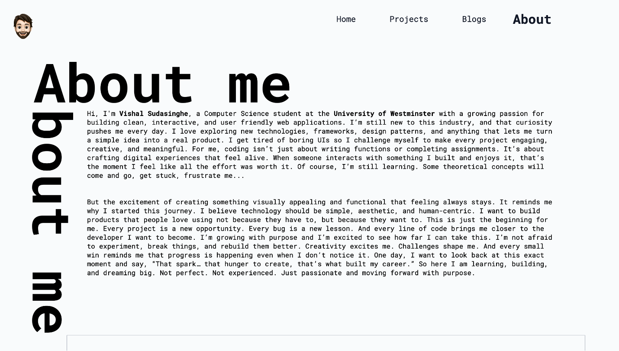

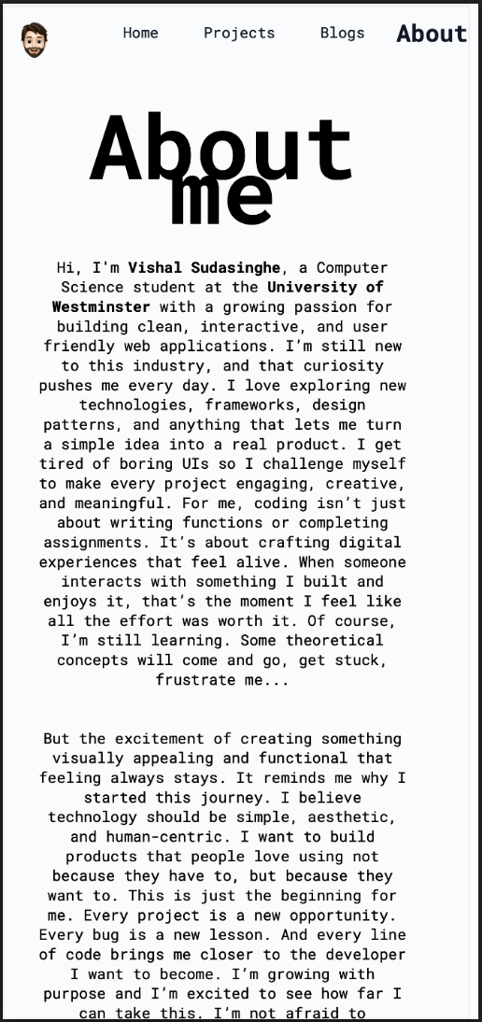 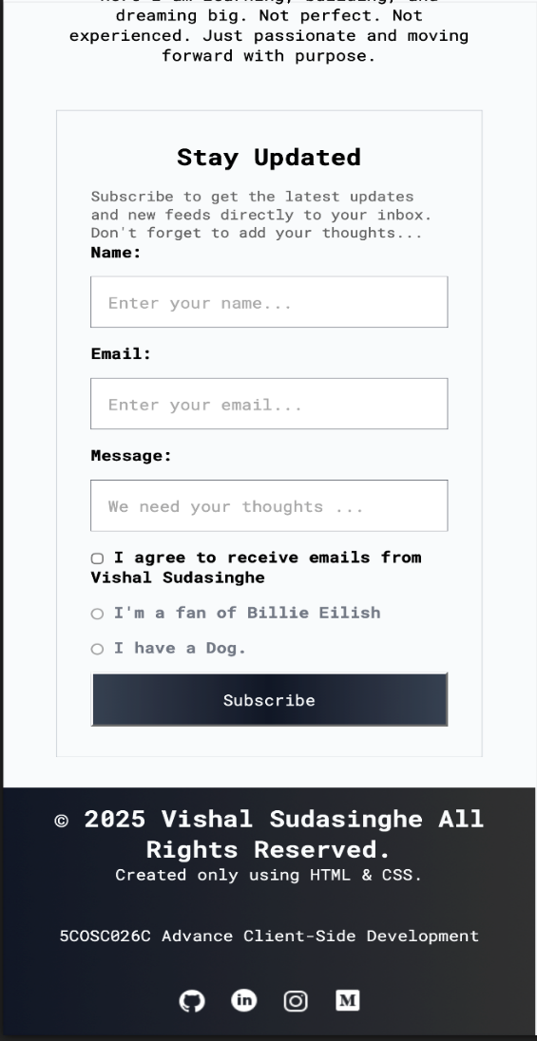

## **Portfolio Code**

### Index.html

### Projects.html

### Blogs.html

### About.html

### Styles.css

## **Diary**

**26/ 09/ 2025 - 10:01 am**

Designing is something that I am truly passionate of, so started this project with a lot of energy. For the past six months, I have been doing on several full design projects most of which were based on my client’s opinions. This time however I wanted to try something different, using only a minimal color pallet. In this design , I chose just black and white to create the notebook like feeling.

When I begin working on a design I can go the entire day without even looking at the clock,completely immersed until I come up with something atleat close to the idea I have in my mind.After two hours of focused work, this is the desigh I created. (I know that this will change atleat 5 times when I’m coming up with the last design.)

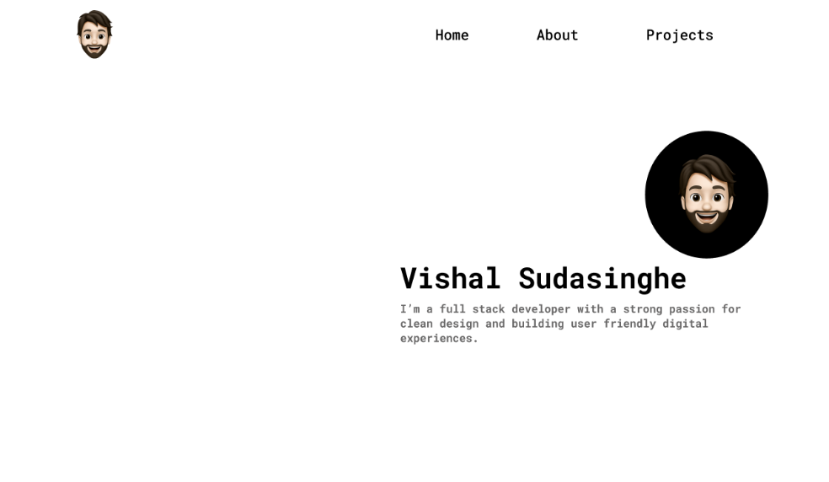

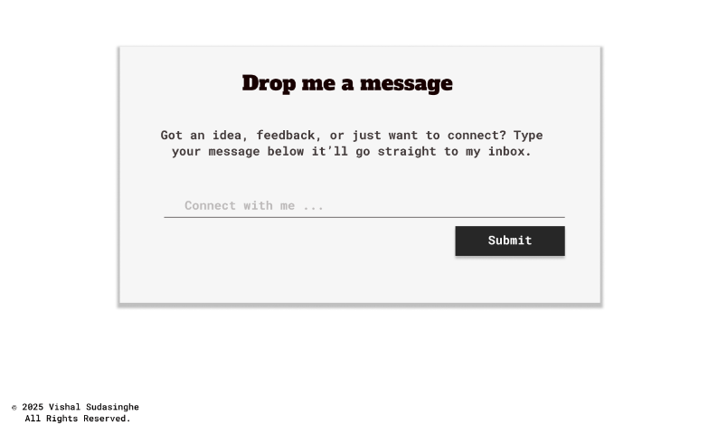

**27/ 09/ 2025 - 9:20 am**

Today I began working on the coding aspect of the project. The main challenge I encountered was adapting back to standard CSS, as I’ve primarily using Tailwind CSS for a long time. This transition initially caused some confusion, particularly when I mistakenly expected classes like bg-gray-100 to work in plain CSS.  
For the design, my objective was to create a clean yet dynamic interface, to achieve this,

* I incorporated an emoji that changes its angle on hover, adding an interactive element.
* The typography was styled using Roboto Mono and Alfa Slab One.
* The navigation bar was positioned using flex-end property.
* Social media icons were arranged through combination of margins and flex layout.  
  The emoji was placed using absolute positioning.
* To maintain the sharp and minimal look, I intentionally avoided using border-radius.

**29/ 09/ 2025 - 7:30 am**

After reviewing the coursework specification, I realized that the previously designed project page need some modifications to align the design more closely with standard practices, I restructured the page to resemble a typical events page.

Key improvements included :  
- Replacing generic <div> elements with semantic HTML elements such as **<article>,** **<section>, <mark>** and **<date>** for better readability and accessibility.

Using **<figure>** and **<figcaption>** to store and describe project images, ensuring that both content and structure adhere to semantic conversions.

At first I was quite confused about why we are encouraged to use semantic elements like <section> and <article> when **<div>** appears to serve the same purpose visually. After spending some time exploring this with ChatGPT, I realized that although these elements behave similarly in terms of layout, real importance lies beyond the appearance.

Semantic elements provide meaningful structure to the document, malign it easier for browsers, screen readers, and search engines to interpret the content accurately. This is not only improves accessibility and SEO but also enhance the maintainability of the code by clearing defining the purpose of each section.

In conclusion, the use of semantic elements adds significant value by improving both the usability and the overall quality of a webpage.

<mark>

<date>

<p>

<h1>

<article>

Hovering effect

grayscale()

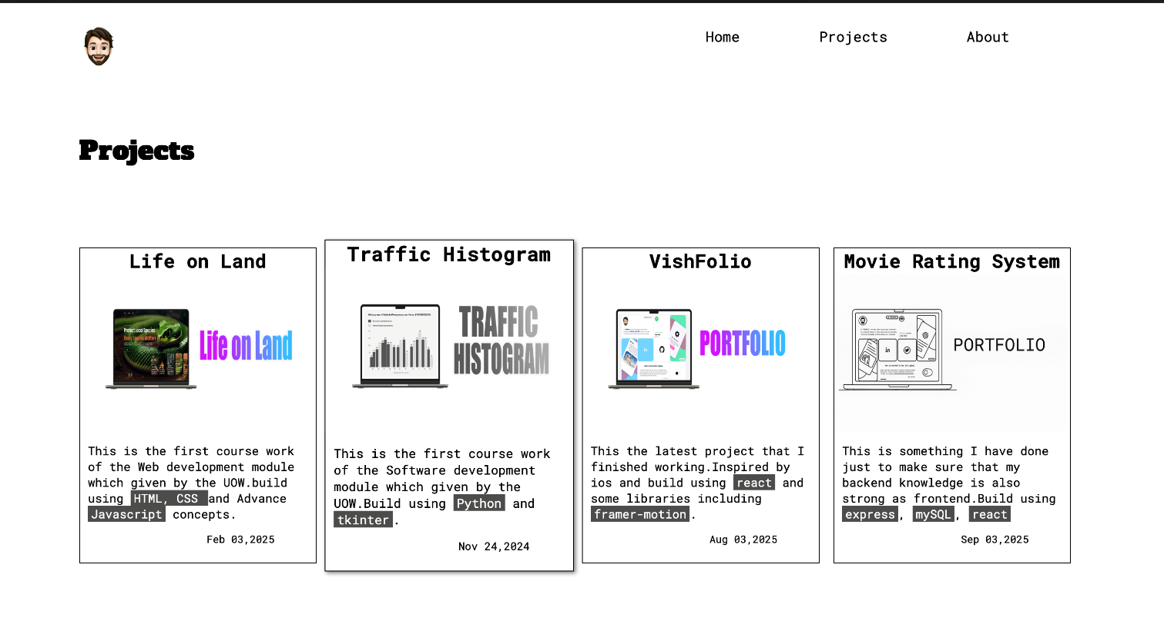

**30/ 09/ 2025 - 9:30 am**

Today I started working on the footer design, Since the website only consist of three pages,there was no need to include a full site map as typically seen in larger websites. Instead, I designed a simpler yet visually appealing footer.

To enhance the appearance, I avoided using a solid black background and instead applied a black-to-gray gradient, which creates a smoother and modern visual effect**.**

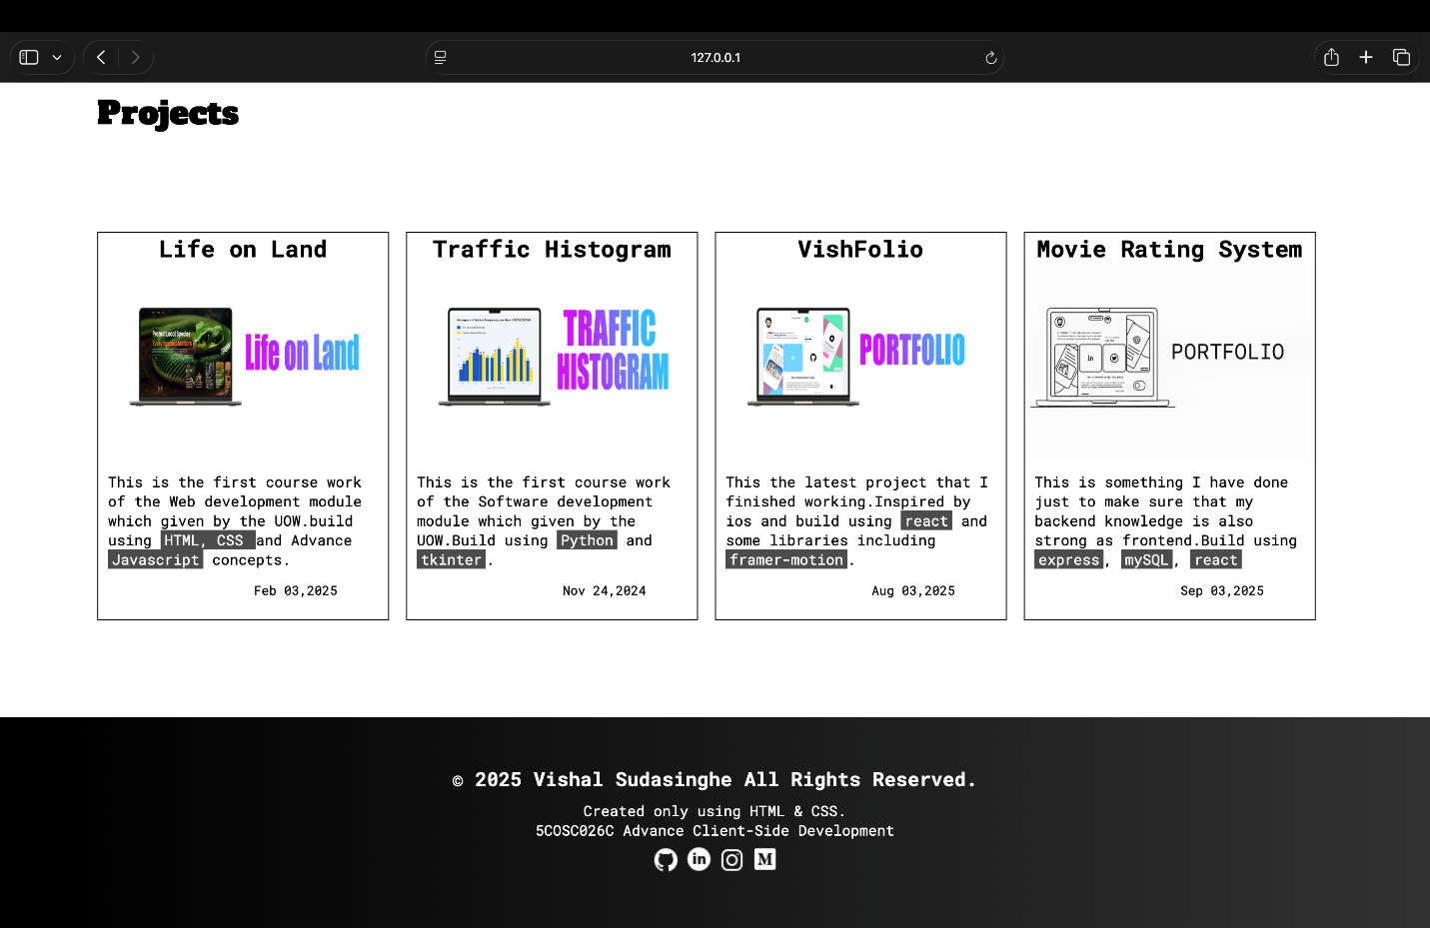

**04/ 10/ 2025 - 3:00 am**

After reviewing several professional level websites, I realized that my portfolio needed some significant improvements. The first major change I made was selecting a dark yet visually appealing color theme to give the entire website a more modern and polished look. Additionally, I enhanced the About page adding a form.



--charcoal: #111827ff;

--steel: #1f2937ff;

--slate: #374151ff;

--cool-gray: #9ca3afff;

--off-white: #f9fafbff;

--oxford-blue: #1b263bff;

--purl-orange: #f1856f;

--matte-green: #afd2a2;

**05/ 10/ 2025 - 2:30 am**

After drawing inspiration from the website reviewed on the previous day, I refined several aspects of the design. Additionally, I implemented fully mobile responsiveness across the Home, Project, and About pages to ensure optimal performance and accessibility on various screen sizes.

**Home Page**

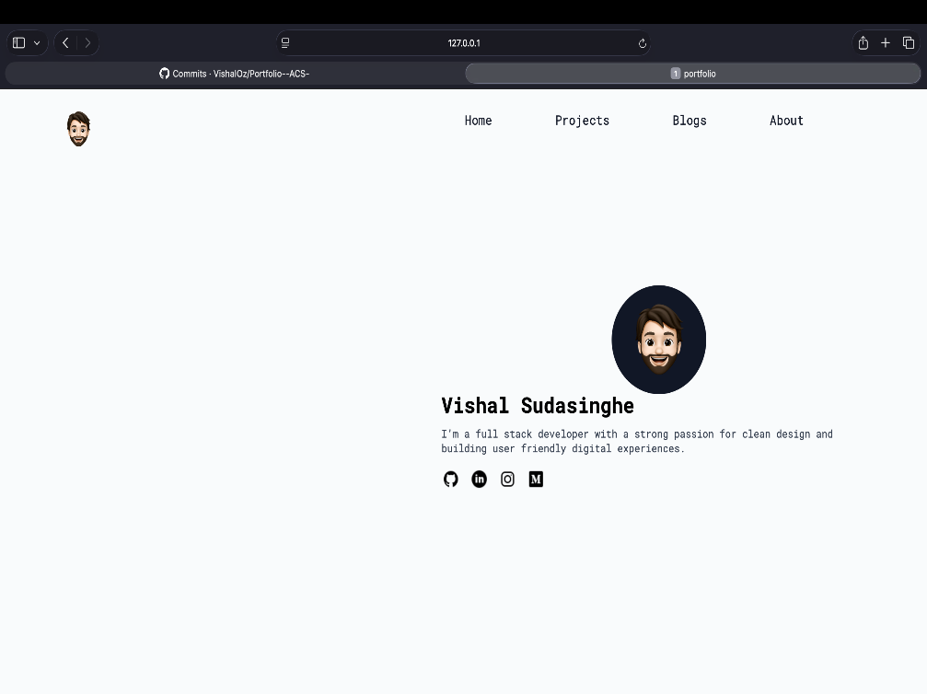

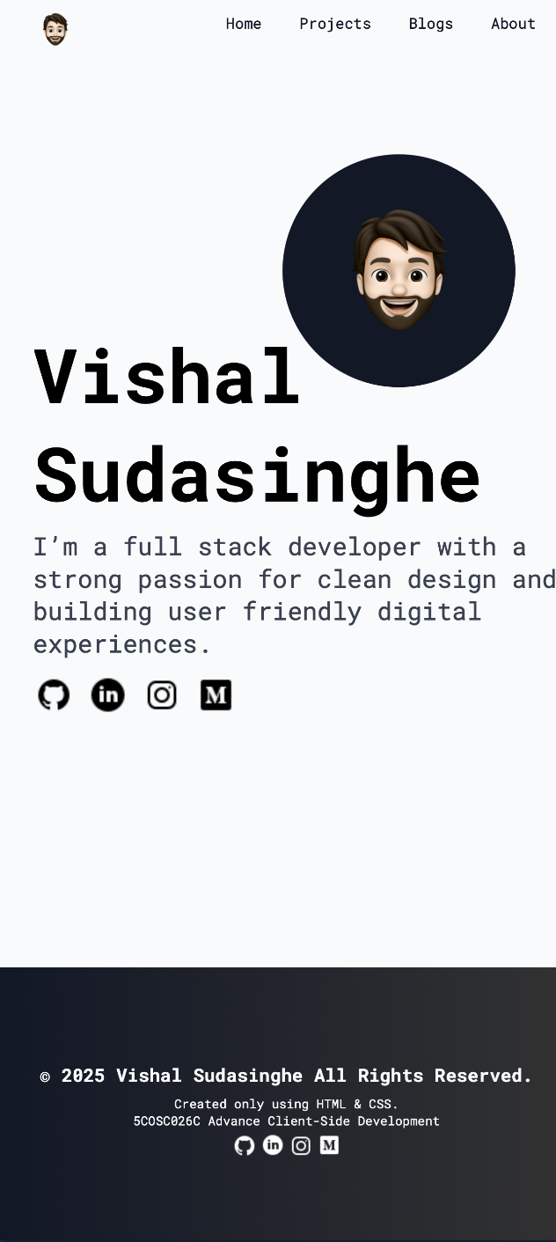

**About Page**

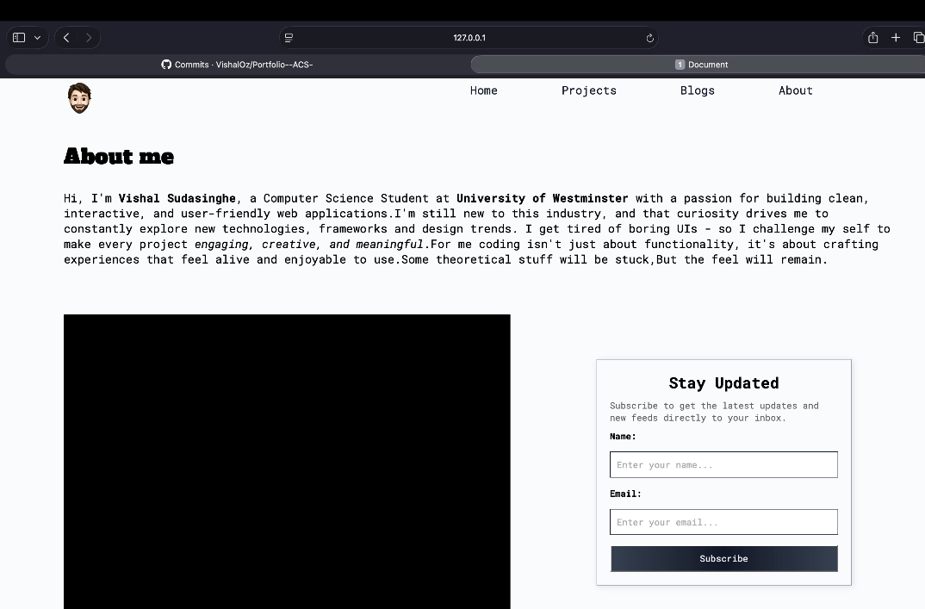

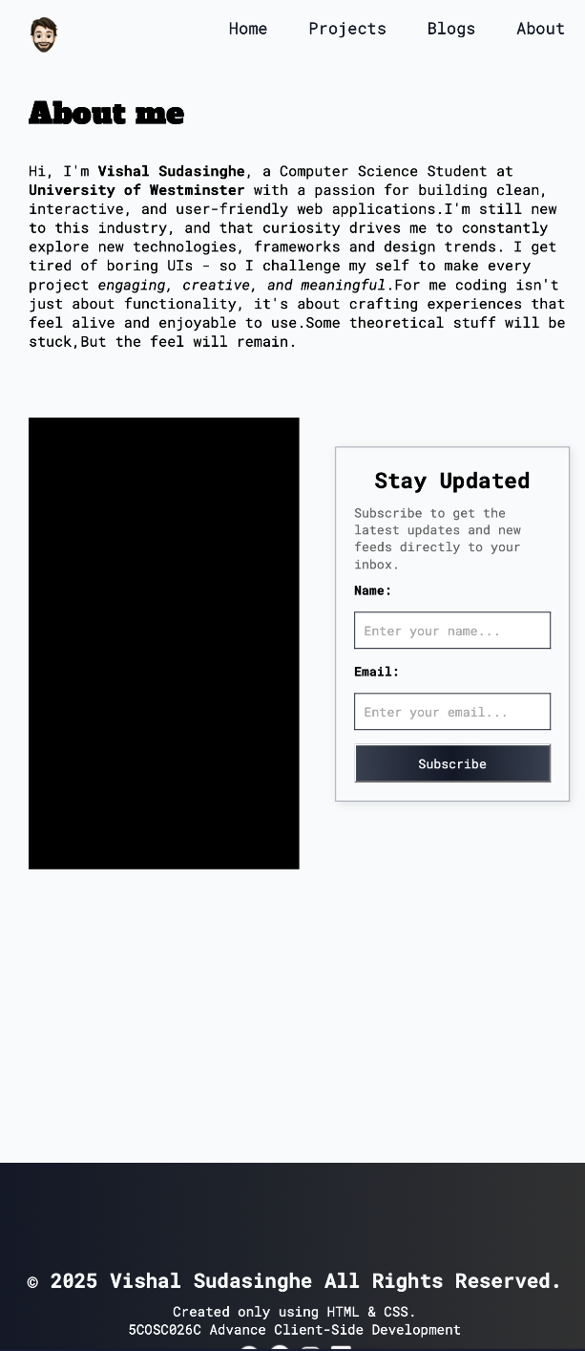

**Projects Page**

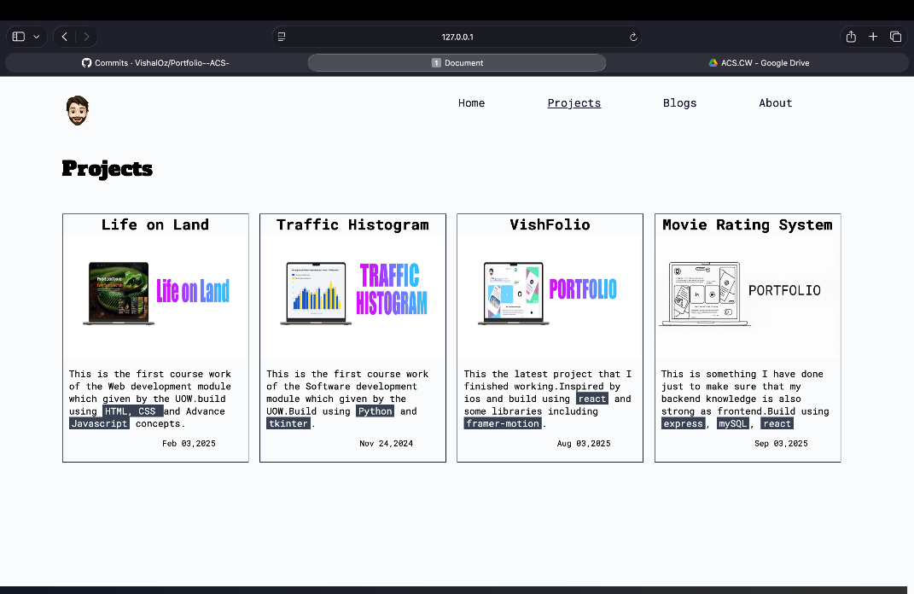

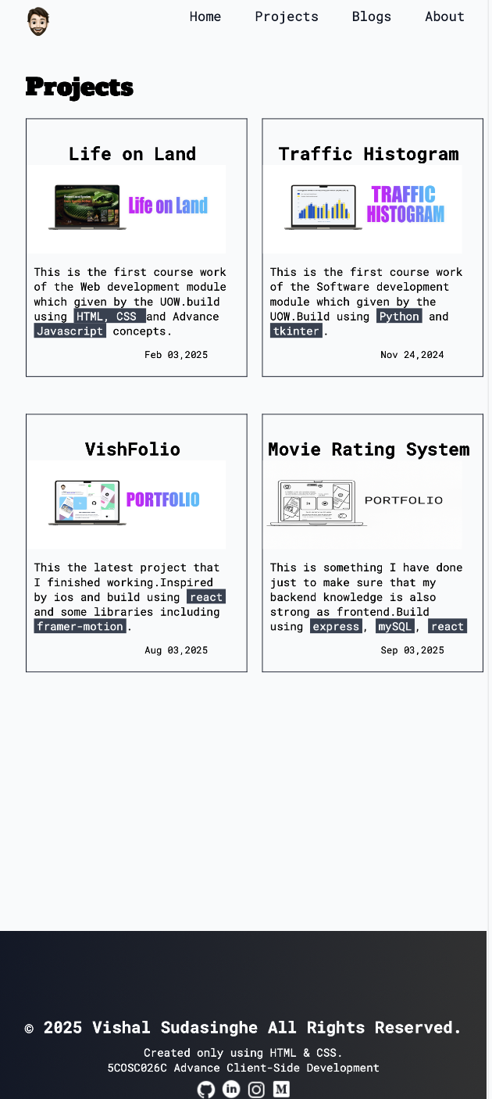

**26/ 10/ 2025**

Today I reviewed my previous implementation and identified a major design issue , I had used hard coded pixel values throughout the stylesheet. This is approach caused layout inconsistence across different screen sizes, negatively affecting responsiveness. To resolve this, I systematically replaced every pixel values with scalable units such as rem, ensuring more flexible and accessible design structure.

And I made some design changes too.

|  |  |
| --- | --- |
| Before | After |
|  |  |
|  |  |
|  |  |
|  |  |

**27/ 10/ 2025**

After converting the style units, I built the entire website using rem units to achieve full responsiveness, I performed several viewpoint tests using browser developer tools to verify that the layout and the typography scaled appropriately across various devices and screen resolutions.

**28/ 10/ 2025**

On this day, I enhanced the website by adding new UI components, including three interactive blog cards and subtle animations(Emoji animation in the home page). These additions were made the project requirements stated in the coursework specification and to improve use engagement and overall visual appeal.

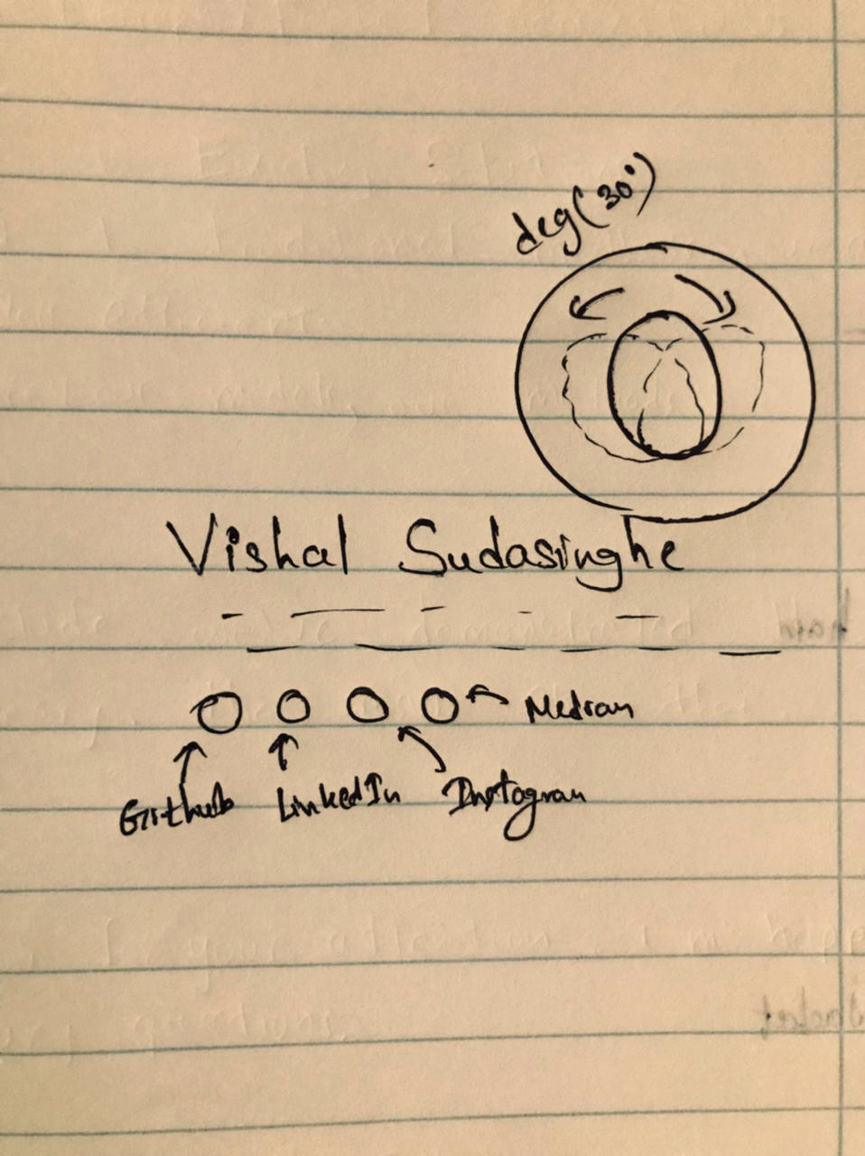

**30 / 10/ 2025**

I refined the website’s structure by removing unnecessary standalone form pages . Instead, I integrated the form section into the exiting “About” page. This modification simplified the site’s navigation flow and reduced redundancy, resulting in a cleaner and more user-friendly interface.

**31 / 10/ 2025**

I conducted formal HTML and CSS validation using the W3C Validator to ensure code quality and compliance with web standards. Several syntax errors and minor warnings were identified and corrected. I also documented the validation results and included screenshots of the validation reports as evidence in the final project documentation. (5. Code validation )

**01 / 11/ 2025**

Today I finalized the entire project, performing a final quality assurance check to confirm that all functionalities, animations, and responsiveness were working as expected, then I updated the version history and development log in the report to reflect the complete progression of the report.

# **CSS Implementation**

You are required to use the following:

1. ~~Specify font(s) to be used throughout the site and in more specific areas, using either @font-face or google fonts~~
2. ~~Colors (including at least one semi-transparent)~~
3. ~~Shadows~~
4. ~~Text effects~~
5. ~~Attribute selectors (minimum 2)~~
6. ~~Pseudo elements with~~ **~~generated content~~** ~~in at least one place on your site~~
7. ~~User action pseudo class~~
8. ~~Child combinator~~
9. ~~Structural selectors~~
10. ~~Negation pseudo class~~
11. ~~Nth pseudo class~~
12. ~~Validity pseudo class~~
13. ~~Relational selector~~
14. ~~Border~~
15. ~~Rounded corners (can be of size 0 if you do not wish to have rounded corners)~~
16. ~~Gradient~~
17. ~~Transforms~~
18. ~~Transitions~~
19. ~~Animations~~
20. ~~Show that you have taken specificity into consideration~~

Provide good comments and indentation

Imported Roboto-Mono, Alfa-Slab, Bebas fonts

@import url('https://fonts.googleapis.com/css2?family=Bebas+Neue&family=Roboto+Mono:ital,wght@0,100..700;1,100..700&family=Space+Grotesk:wght@300..700&display=swap');

@import url('https://fonts.googleapis.com/css2?family=Alfa+Slab+One&family=Bebas+Neue&family=Roboto+Mono:ital,wght@0,100..700;1,100..700&family=Space+Grotesk:wght@300..700&display=swap');

Used Shadows in Projects page

.projectsSec:hover,

.projectsSecMain:hover {

box-shadow: 0 4px 8px rgba(0, 0, 0, 0.2);

cursor: pointer;

transform: scale(1.02);

transition: transform 0.3s ease, box-shadow 0.3s ease;

}

Attribute Selectors,

.subscribeForm input[type="text"],

.subscribeForm input[type="email"],

.subscribeForm input[type="textfield"] {

padding: 1rem;

border: 0.1px solid var(--charcoal);

font-size: 1rem;

outline: none;

}

Structural Selectors,

.projectsSecCont > article:first-child {

border: 1px solid var(--off-white);

padding: 2rem;

}

.projectsSecCont > article:last-child {

border: 1px solid var(--off-white);

padding: 2rem;

}

Pseudo-elements with generated content

.buttonCont button::after {

content: ' →';

position: relative;

left: 0;

transition: left 0.3s ease;

}

.buttonCont button:hover::after {

left: 0.2rem;

}

User action pseudo class,

.subscribeForm input:focus {

border: 0.2rem solid var(--charcoal);

}

.projectsSec:hover,

.projectsSecMain:hover {

box-shadow: 0 4px 8px rgba(0, 0, 0, 0.2);

cursor: pointer;

transform: scale(1.02);

transition: transform 0.3s ease, box-shadow 0.3s ease;

}

Validity pseudo class,

form:has(input:invalid) button {

opacity: 0.5;

pointer-events: none;

}

form:has(input:valid) button {

opacity: 1;

pointer-events: auto;

}

<form class="subscribeForm">

<label>Name: </label>

<input type="text" name="name" id="name" placeholder="Enter your name..." required/>

<label>Email: </label>

<input type="email" name="email" id="email" placeholder="Enter your email..." required/>

<label>Message: </label>

<input type="text" class="message" placeholder="We need your thoughts ..."/>

<div class="conditionDiv">

<input type="checkbox" id="checkBox" name="checkBox" />

<label class="condition">I agree to receive emails from Vishal Sudasinghe </label>

</div>

<div class="radioDiv">

<input type="radio" id="fan1" name="fan1" value="fan1" >

<label>I'm a fan of Billie Eilish</label>

</div>

<div class="radioDiv">

<input type="radio" id="fan1" name="fan1" value="fan1" >

<label>I have a Dog.</label>

</div>

<button type="submit">Subscribe</button>

</form>

Animations (@keyframes),

@keyframes tilt {

0% {

transform: rotate(10deg);

}

25% {

transform: rotate(-10deg);

}

50% {

transform: rotate(10deg);

}

75% {

transform: rotate(-10deg);

}

100% {

transform: rotate(10deg);

}

}

Transforms,

nav ul li:not(.navLogo) a:hover {

transform: scale(1.6);

color: var(--cool-gray);

}

nav ul li a.active {

transform: scale(1.6);

font-weight: bold;

}

Gradient,

footer {

width: 100%;

background-image: linear-gradient(to right, var(--charcoal) , rgba(0, 0, 0, 0.8));

padding: 2rem 0;

text-align: center;

}

Border,

.subscribeForm input[type="text"],

.subscribeForm input[type="email"],

.subscribeForm input[type="textfield"] {

padding: 1rem;

border: 0.1px solid var(--charcoal);

font-size: 1rem;

outline: none;

}

Child combinator,

nav > ul > li > a{

text-decoration: none;

color: var(--charcoal);

transition: transform 0.3s ease;

display: inline-block;

}

Rounded corners,

border-radius: 8px

Specificity considered,

Many areas using > and element > class

Nth pseudo class,

.secondMainCont article:nth-child(3) {

margin-bottom: 5rem;

}

Negation pseudo class,

.projectSecCont > article:not(.projectsSecMain) {

border: 2px solid var(--slate);

}

# **Code Validation**

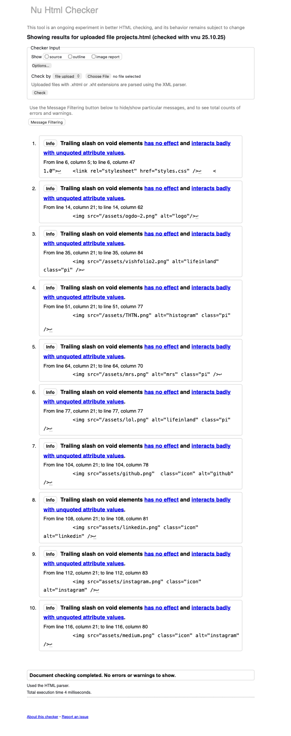

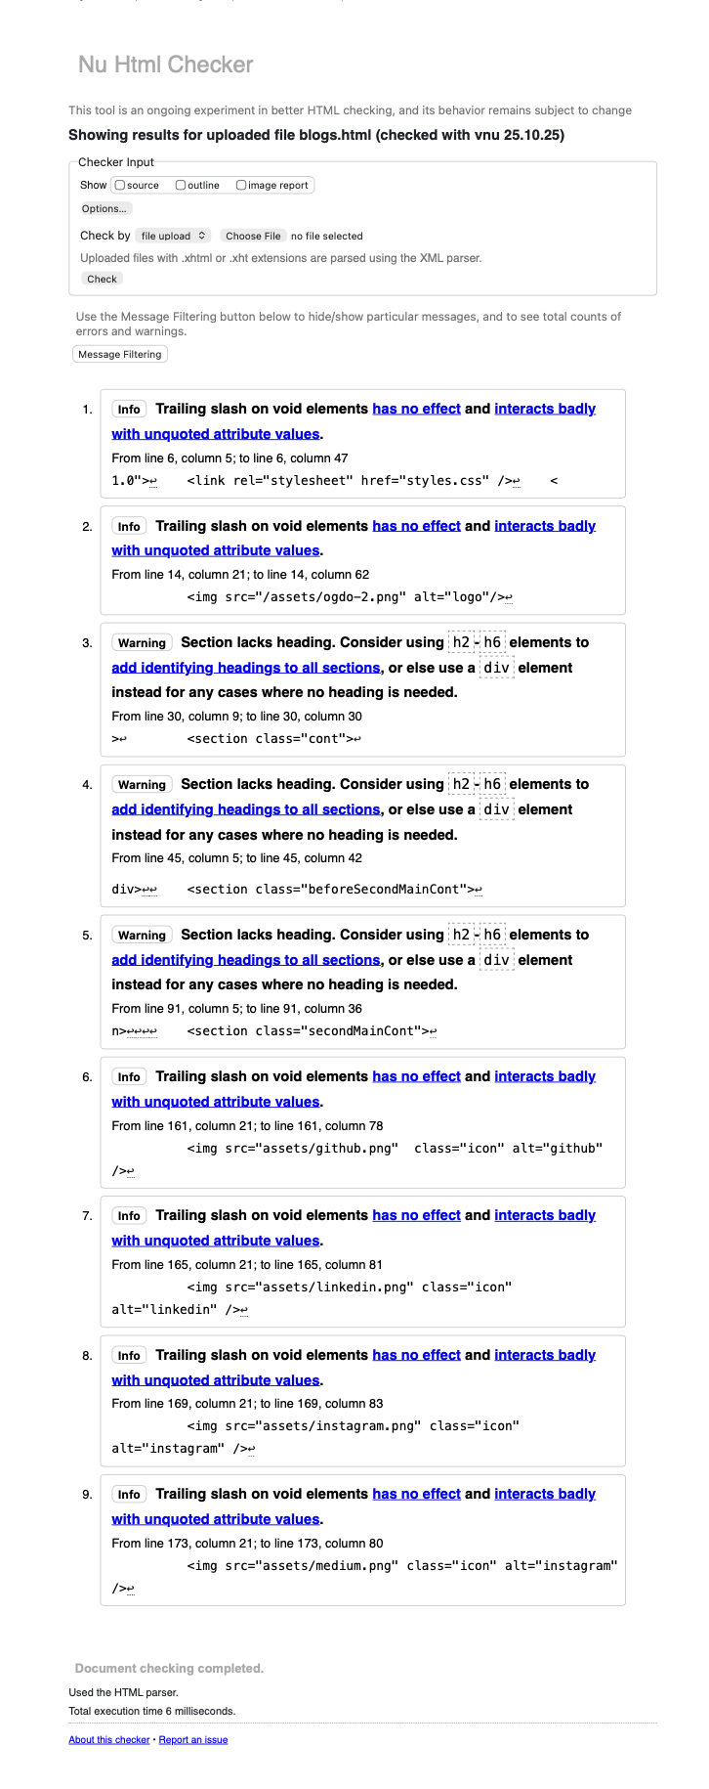

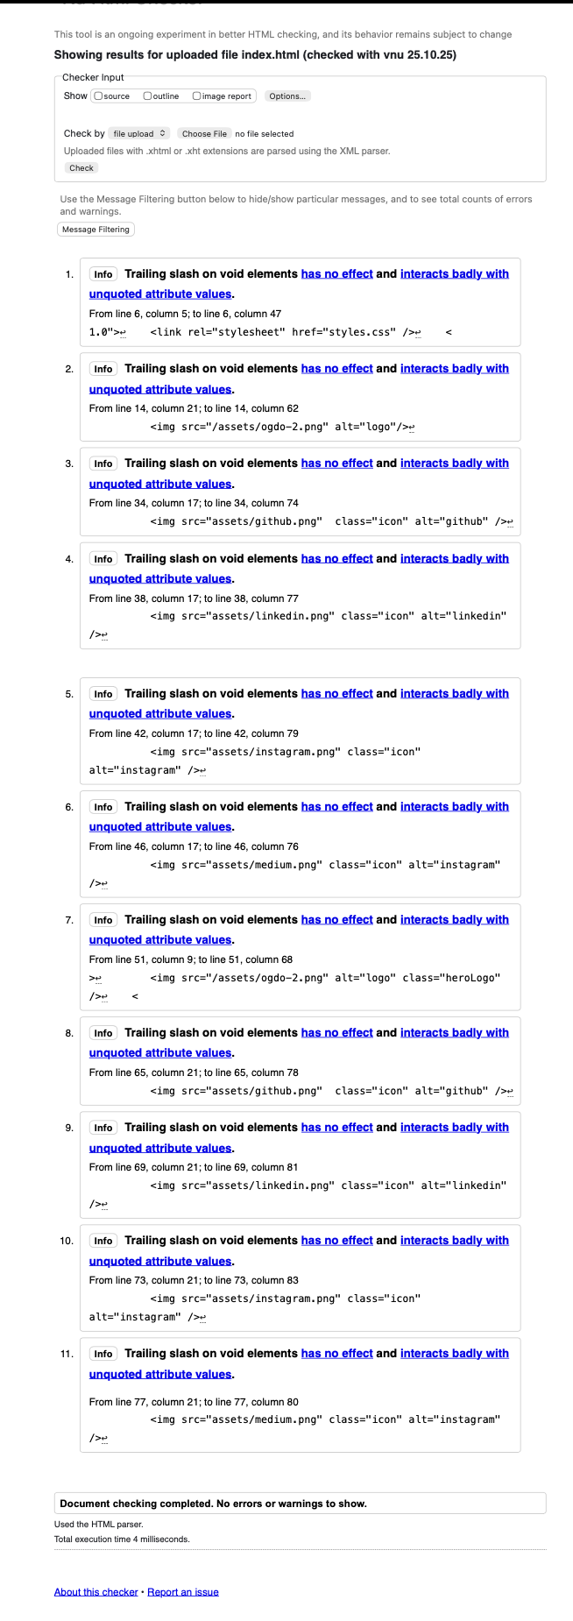

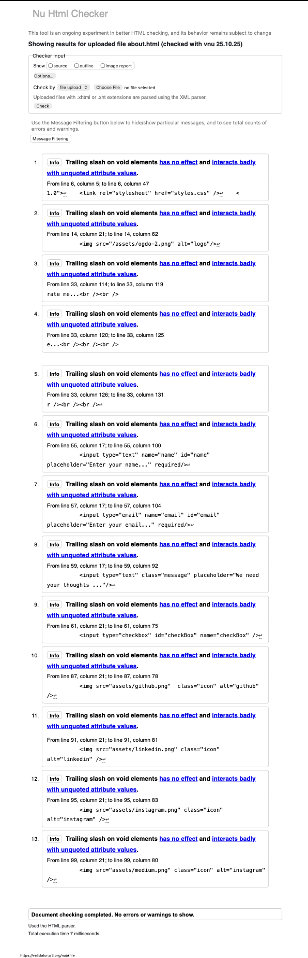

# **Version history**

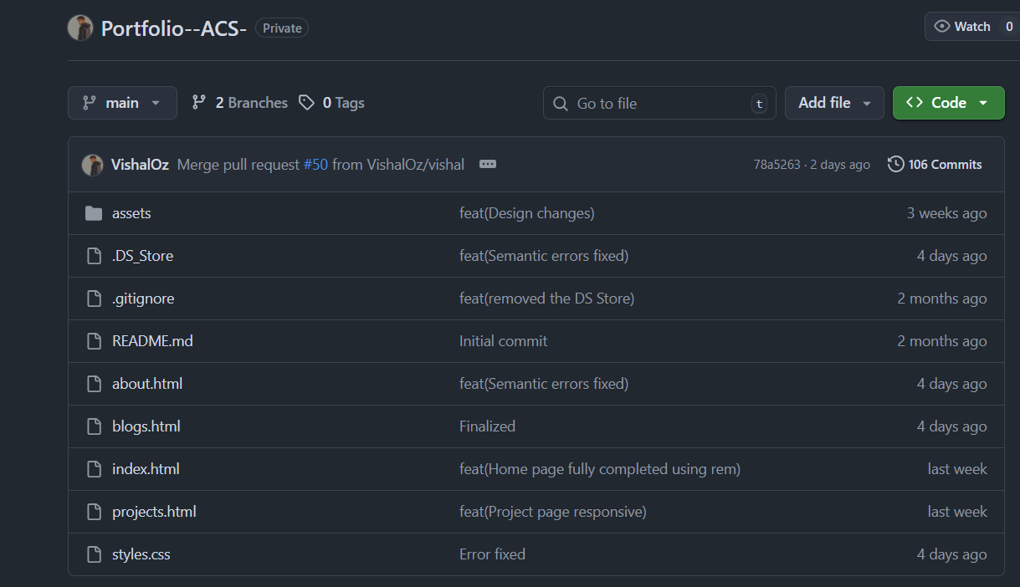

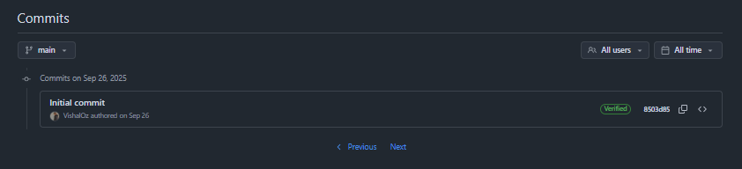

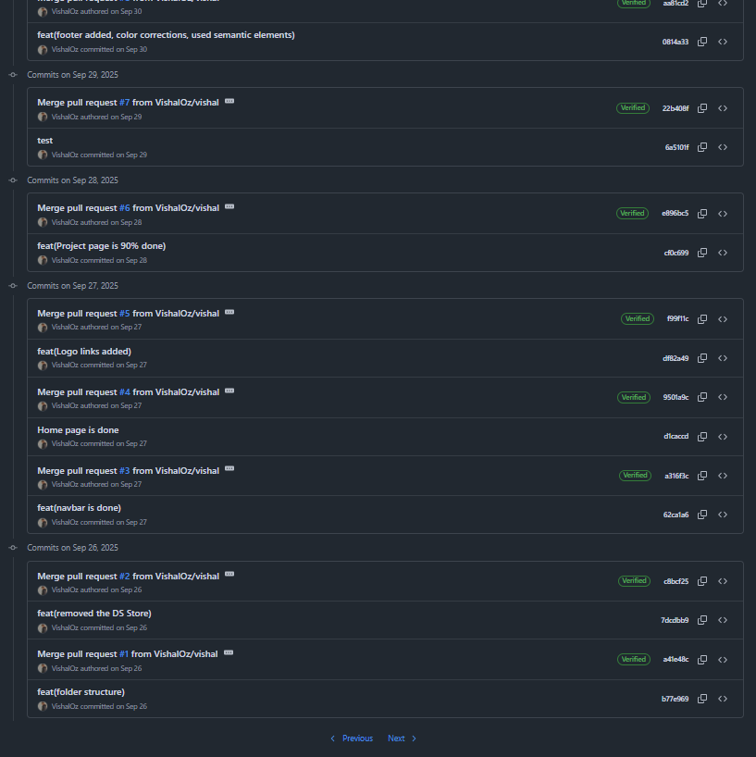

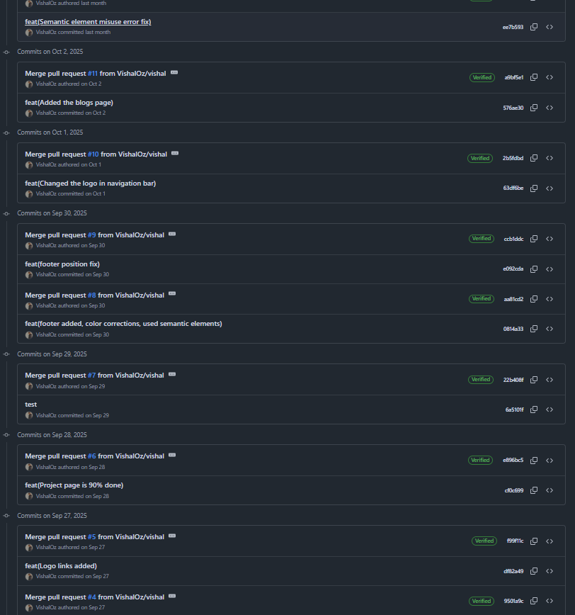

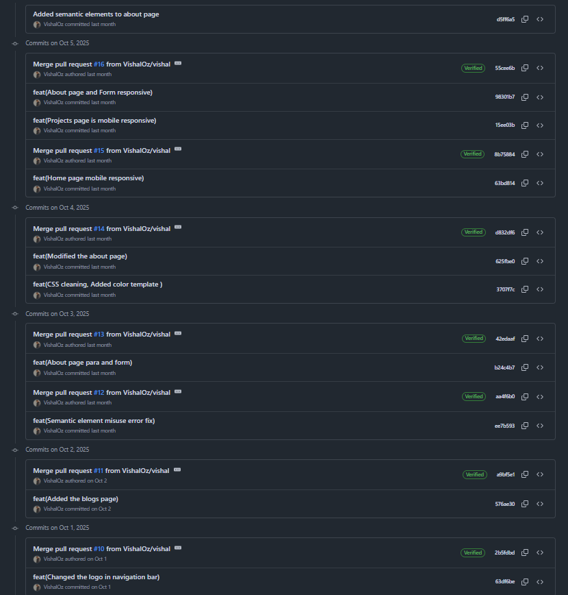

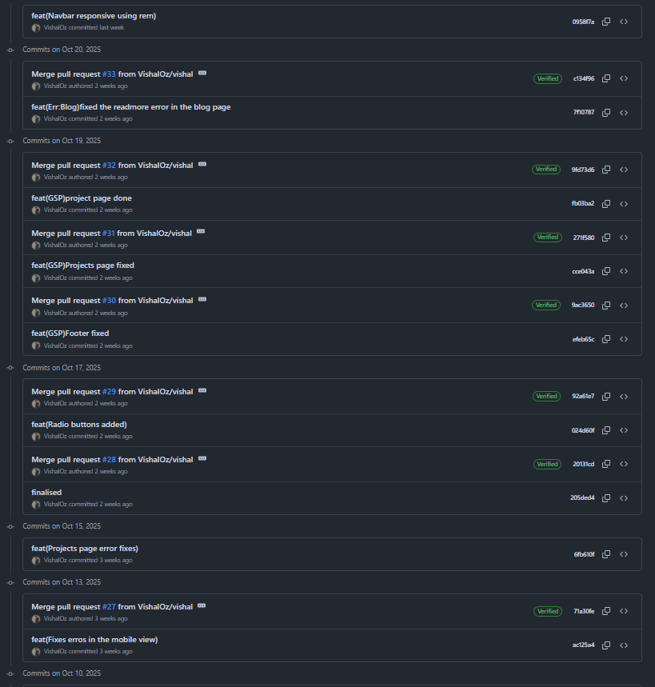

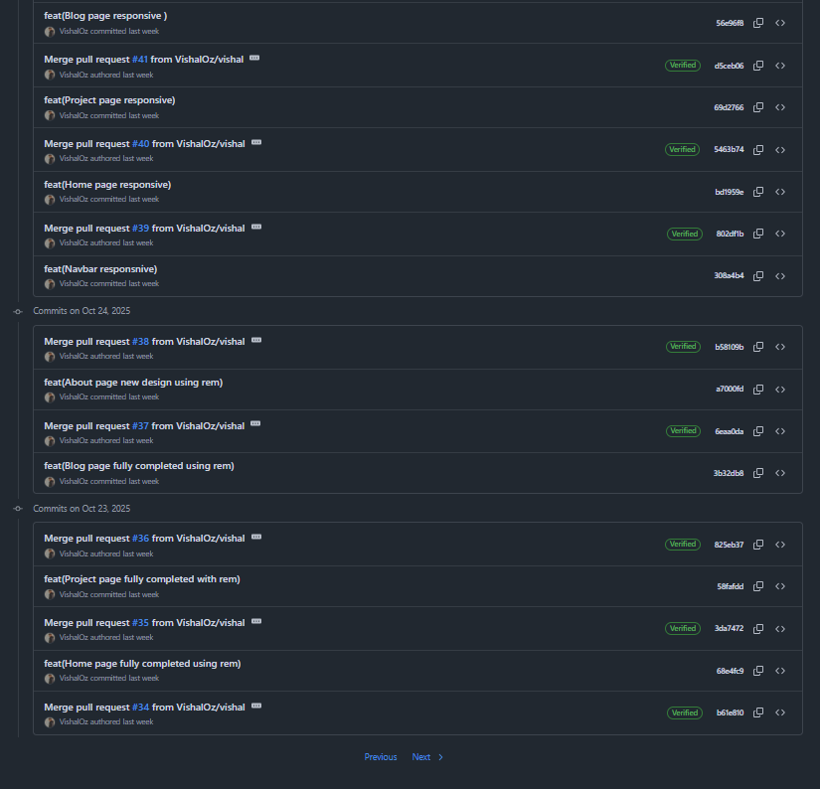

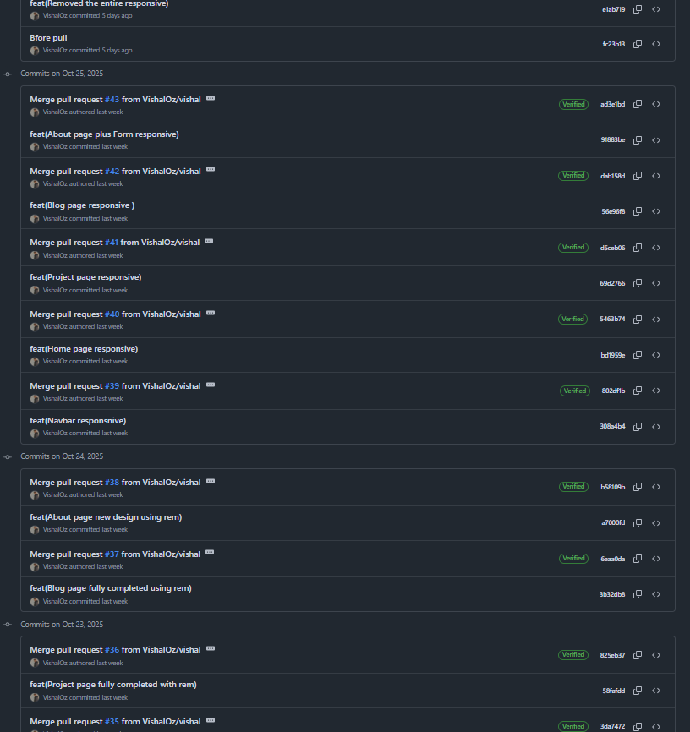

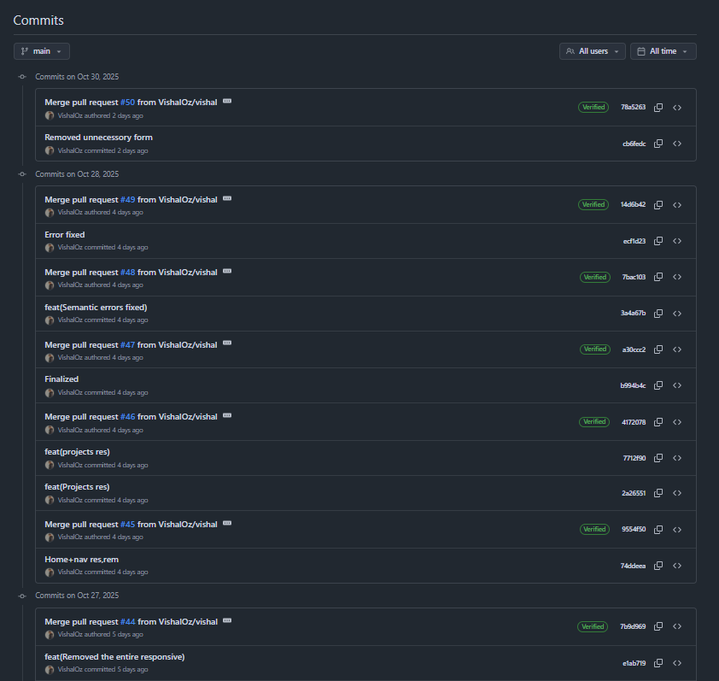

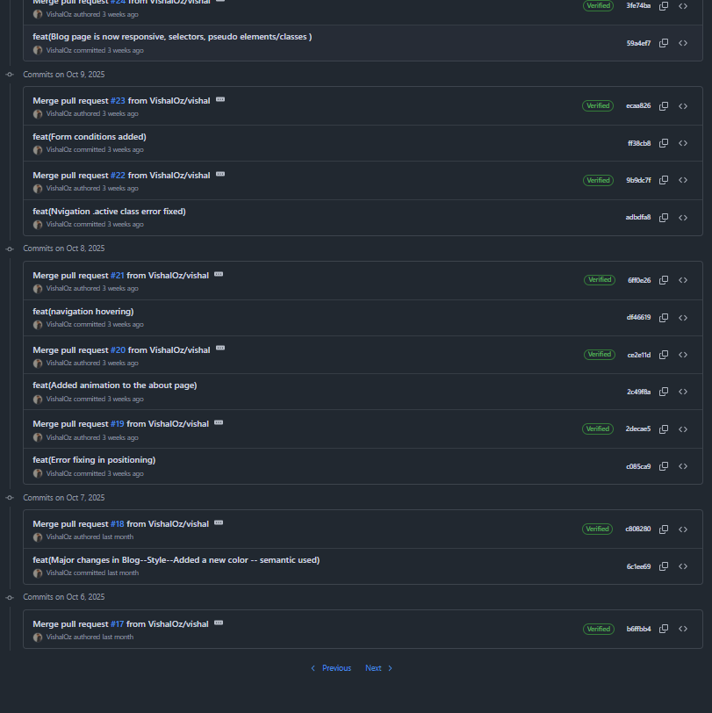

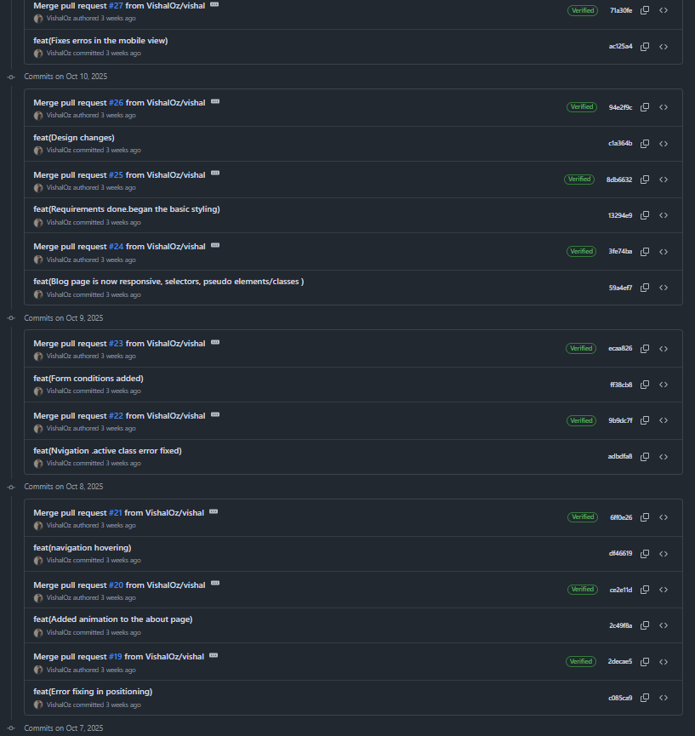

# **References**

* + Jake Sinclair Portfolio . [https://www.jakesinclair.ca/](https://www.jakesinclair.ca/%20)
  + W3Schools. HTML Tutorial. Available from <https://www.w3schools.com/html/default.asp>

[Accessed 04 October - 04 October 2025]

* + W3Schools. CSS Tutorial. Available from <https://www.w3schools.com/css/default.asp>

[Accessed 04 October - 04 October 2025]

* + Google fonts. <https://fonts.google.com/> [Accessed 04 October 2025]
  + HTML5 Validator. <http://validator.w3.org/> [Accessed 04 November 2025]
  + CSS Lint. <http://csslint.net/> [Accessed 04 November 2025]